History Of American Football

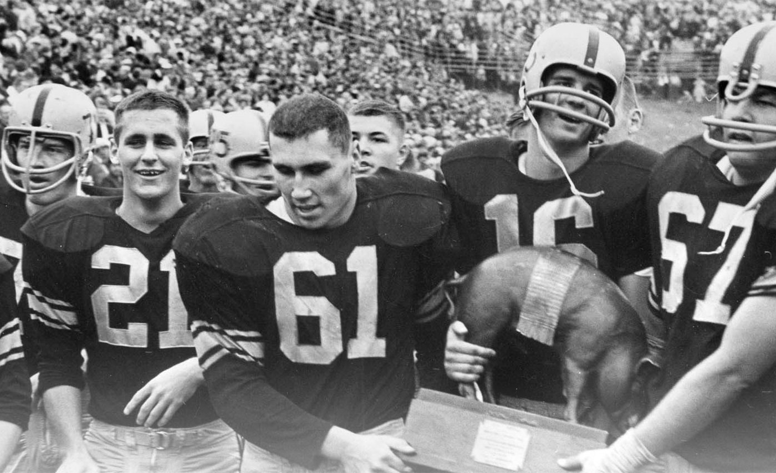

The history of American football can be traced to early versions of [rugby football](https://en.wikipedia.org/wiki/Rugby_football) and [association football](https://en.wikipedia.org/wiki/Association_football). Both games have their origin in varieties of [football](https://en.wikipedia.org/wiki/Football) played in Britain in the mid-19th century, in which a [football](https://en.wikipedia.org/wiki/Football_(ball)) is kicked at a [goal](https://en.wikipedia.org/wiki/Goal) or kicked over a line, which in turn were based on the varieties of [English public school football games](https://en.wikipedia.org/wiki/English_public_school_football_games).

[American football](https://en.wikipedia.org/wiki/American_football) resulted from several major divergences from association football and rugby football, most notably the rule changes instituted by [Walter Camp](https://en.wikipedia.org/wiki/Walter_Camp), a [Yale University](https://en.wikipedia.org/wiki/Yale_University) and Hopkins School graduate who is considered to be the "Father of American Football". Among these important changes were the introduction of the [line of scrimmage](https://en.wikipedia.org/wiki/Line_of_scrimmage), of [down-and-distance](https://en.wikipedia.org/wiki/Down_(American_football)) rules and of the legalization of [interference](https://en.wikipedia.org/wiki/Blocking_(American_football)). In the late 19th and early 20th centuries, gameplay developments by college coaches such as [Eddie Cochems](https://en.wikipedia.org/wiki/Eddie_Cochems), [Amos Alonzo Stagg](https://en.wikipedia.org/wiki/Amos_Alonzo_Stagg), [Parke H. Davis](https://en.wikipedia.org/wiki/Parke_H._Davis), [Knute Rockne](https://en.wikipedia.org/wiki/Knute_Rockne), and [Glenn "Pop" Warner](https://en.wikipedia.org/wiki/Glenn_Scobey_Warner) helped take advantage of the newly introduced [forward pass](https://en.wikipedia.org/wiki/Forward_pass). The popularity of [college football](https://en.wikipedia.org/wiki/College_football) grew as it became the dominant version of the sport in the United States for the first half of the 20th century. [Bowl games](https://en.wikipedia.org/wiki/Bowl_game), a college football tradition, attracted a national audience for college teams. Boosted by fierce [rivalries](https://en.wikipedia.org/wiki/List_of_NCAA_college_football_rivalry_games) and colorful traditions, college football still holds widespread appeal in the United States.

The origin of [professional football](https://en.wikipedia.org/wiki/Professional_football_(gridiron)) can be traced back to 1892, with [William "Pudge" Heffelfinger's](https://en.wikipedia.org/wiki/William_Heffelfinger) $500 contract to play in a game for the [Allegheny Athletic Association](https://en.wikipedia.org/wiki/Allegheny_Athletic_Association) against the [Pittsburgh Athletic Club](https://en.wikipedia.org/wiki/Pittsburgh_Athletic_Club_(football)). In 1920 the American Professional Football Association was formed. This league changed its name to the [National Football League](https://en.wikipedia.org/wiki/National_Football_League) (NFL) two years later, and eventually became the [major league](https://en.wikipedia.org/wiki/Major_North_American_professional_sports_leagues) of American football. Primarily a sport of Midwestern industrial towns in the United States, professional football eventually became a national phenomenon.

The modern era of American football can be considered to have begun after the [1932 NFL Playoff game](https://en.wikipedia.org/wiki/1932_NFL_Playoff_game), which was the first American football game to feature [hash marks](https://en.wikipedia.org/wiki/Hash_marks), the legalization of the forward pass anywhere behind the line of scrimmage, the first indoor game [since 1902](https://en.wikipedia.org/wiki/World_Series_of_Football_(1902%E2%80%9303)), and the movement of the goal posts back to goal line. Other innovations to occur immediately after 1932, were the introduction of the [AP Poll](https://en.wikipedia.org/wiki/AP_Poll) in 1934, the tapering of the ends of the football in 1934, the awarding of the first [Heisman Trophy](https://en.wikipedia.org/wiki/Heisman_Trophy) in 1935, the first [NFL draft in 1936](https://en.wikipedia.org/wiki/1936_NFL_draft) and the [first televised game in 1939](https://en.wikipedia.org/wiki/1939_Waynesburg_vs._Fordham_football_game). Another important event was the American football game at the [1932 Summer Olympics](https://en.wikipedia.org/wiki/1932_Summer_Olympics), which combined with a similar demonstration game at [1933 World's Fair](https://en.wikipedia.org/wiki/1933_World%27s_Fair), led to the first [College All-Star Game](https://en.wikipedia.org/wiki/College_All-Star_Game) in 1934, which in turn was an important factor in the growth of [professional football](https://en.wikipedia.org/wiki/Professional_football_(gridiron)) in the United States. American football's explosion in popularity during the second half of the 20th century can be traced to the [1958 NFL Championship Game](https://en.wikipedia.org/wiki/1958_NFL_Championship_Game), a contest that has been dubbed the "Greatest Game Ever Played". A rival league to the NFL, the [American Football League](https://en.wikipedia.org/wiki/American_Football_League) (AFL), began play in 1960; the pressure it put on the senior league led to a [merger](https://en.wikipedia.org/wiki/AFL%E2%80%93NFL_merger) between the two leagues and the creation of the [Super Bowl](https://en.wikipedia.org/wiki/Super_Bowl), which has become the most watched television event in the United States on an annual basis.

